# Blinking of led Using Arduino

# Hardware Required,

* Arduino
* LED
* 220 ohm Resistor

# Circuit

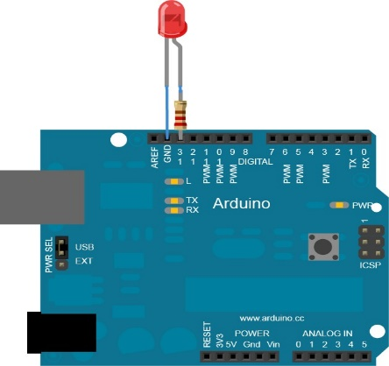The LED is connected to a digital pin and its number may vary from board type to board type. Here we connected the LED to 13th pin of Arduino. Connect the long leg of the LED (the positive leg, called the anode) to the other end of the resistor. Connect the short leg of the LED (the negative leg, called the cathode) to the GND. The value of the resistor in series with the LED may be of a different value than 220 ohm; the LED will lit up also with values up to 1K ohm.

# Schematic

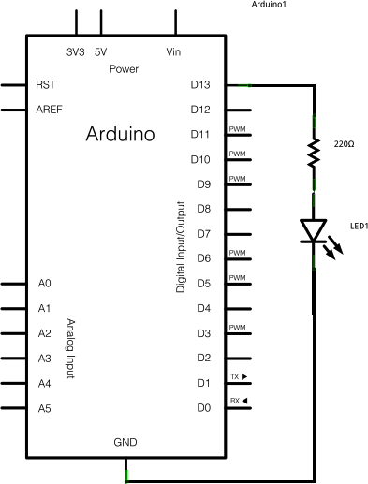

**Code**

After you build the circuit plug your Arduino board into your computer, start the Arduino Software (IDE) and enter the code below. You may also load it from the menu File/Examples/01.Basics/Blink.

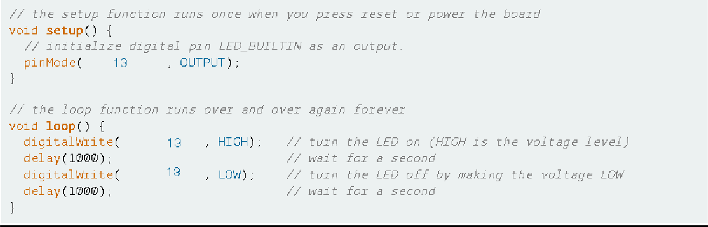

ARDUINO CODE:

void setup()

{

pinMode(13,OUTPUT);

}

void loop()

{

digitalWrite(13,HIGH);

delay(1000);

digitalWrite(13,LOW);

delay(1000);

}

Procedure:

1. Run a black (or dark colored wire) from the Gnd Pin of the Arduino to the Blue Rail on the far side of the Breadboard.

2.Plug an LED bulb into the circuit. Note that the longer pin will face the Arduino Board and the pins should cross the “gap” in the breadboard. (Plug the Long Pin into F5 and the Short Pin into E5).

1. This step is VERY IMPORTANT!!! Plug a 330 OHM resistor from Port B5 to Ground (The blue rail). An LED bulb must ALWAYS have a Resistor in the circuit. If we do not use a Resistor, we will burn out the bulb or the Arduino Board.
2. Now we will run the signal wire. Wire Pin 9 on the Arduino to H5 on the Breadboard. This will carry the current from the Arduino Pin to the LED and allow the Arduino to switch on and off the LED.
3. You are finished! Go on to the next section to program your Arduino.

Open the Arduino IDE software on your computer. Coding in the Arduino language will control your circuit. Open the new sketch File by clicking New.